Name: Sanio Luke Sebastian
Roll No: 35
Batch: B
Date: 08-04-2022

ADVANCED DBMS LAB

Experiment No.: 2

Aim
To familiarize with selecting data from single table.

Questions:

Using the lab cycle 01 database, perform the following queries.

- List all data from table deposit
- List all data from borrow
- List all data from customer
- List all data from branch
- Give account no and amount of deposite
- Give customer name and account no of depositors
- Give name of customers
- Give name of branches
- Give name of borrows
- Give names of customer living in city Nagpur
- Give names of depositors having amount greater than 4000
- Give account date of Anil
- Give name of all branches located in Bombay
- Give name of borrower having loan number l205
- Give names of depositors having account at VRCE
- Give names of all branched located in city Delhi
- Give name of the customers who opened account date ‘1-12-96’
- Give account no and deposit amount of customers having account opened between dates ‘1-12-96’ and ‘1-5-96’
- Give name of the city where branch KAROLBAGH is located
- Give details of customer ANIL

Procedure & Outputs

- select * from deposit;

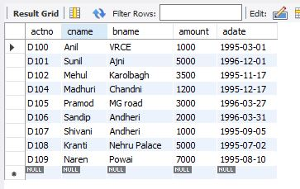

- select * from borrow;

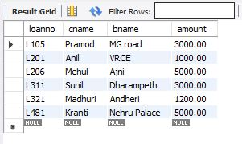

- select * from customer;

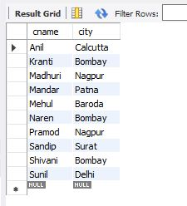

- select * from branch;

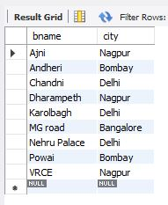

- select actno,amount from deposit;

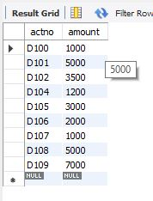

- select cname,actno from deposit;

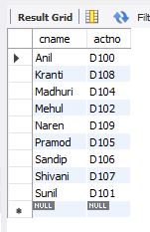

- select cname from customer;

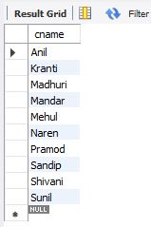

- select bname from branch;

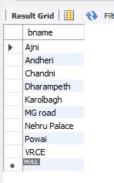

- select cname from borrow;

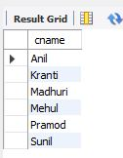

- select cname from customer where city='Nagpur';

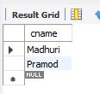

- select cname from deposit where amount > 4000;

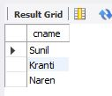

- select adate from deposit where cname='Anil';

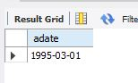

- select bname from branch where city='Bombay';

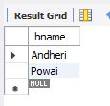

- select cname from borrow where loanno='L201';

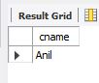

- select cname from deposit where bname='VRCE';

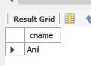

- select bname from branch where city='Delhi';

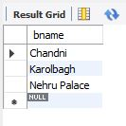

- select cname from deposit where adate='1996-12-01';

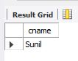

- select cname from deposit where adate between '1996-05-01' and '1996-12-01';

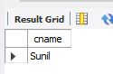

- select city from branch where bname='karolbagh';

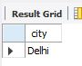

- select * from customer join borrow on customer.cname=borrow.cname join deposit on deposit.cname=borrow.cname WHERE customer.cname='Anil';

